36th Annual Sail for Hospice

Sunday Sept 11, 2022

Sailing Instructions

Hosted by the LaSalle Mariner’s Yacht Club (LMYC) LaSalle, Canada

1 RULES

1.1 The regatta will be governed by the rules as defined in The Racing Rules of Sailing 2021 – 2024. The Prescriptions of Sail Canada will apply. These can be found at http://www.sailing.ca/
1.2 Sailing Instructions will be posted on the LMYC website, and available at LMYC anytime.
1.3 The Essex County PHRF Class Rules will apply http://ec.phrf.ca/rules.html
1.4 The Equipment Rules of Sailing shall be used http://www.sailing.org/documents/equipmentrules/index.php
1.5 The Canadian Shipping Act - Small Vessel Regulation (required safety equipment) shall apply - http://laws-lois.justice.gc.ca/eng/regulations/SOR-2010-91
1.6 Yachts shall carry proper sail numbers on mainsails, spinnakers and any head-sails attached having a luff perpendicular exceeding 130%. Yachts without proper sail numbers shall be subject to protest.

2 ENTRIES
2.1 Competitors may enter by delivering a completed entry form and paying the $50.00 entry fee or $100.00 in pledges to LMYC 2640 Front Road, Lasalle by 11am September 11, 2022. Online registration is possible on the Noticeofrace.net event website. Pledge sheets are available at LMYC, 2640 Front Road, Lasalle or online at http://www.lasallemariners.ca

3 NOTICES TO COMPETITORS
3.1 Changes to the Sailing Instructions will be posted by 2000 hrs Saturday September 10, 2022 on the event website, via NoticeOfRace.net and on the LMYC website
3.2 Changes to class splits will be posted by 12pm Sunday September 11, 2022 at L.M.Y.C., on the event website, and via NoticeOfRace.net

4 DISCLAIMERS of LIABILITY
4.1 Competitors participate in the regatta entirely at their own risk. See Rule 4 of the Racing Rules of Sailing - Decision to Race. The organizing authority will not accept any liability for material damage or personal injury, or death sustained in conjunction with or prior to, during, or after the regatta.

5 INSURANCE
5.1 Each participating boat must carry liability insurance. Proof of Insurance is to be provided as a part of the registration requirements.

6 CUSTOMS
6.1 For US participants not landing or mooring, there is no reporting required. For those who wish to land, the ArriveCAN App must be downloaded and completed. Skippers are responsible for making sure they follow the proper customs procedures for their boat and crew. The organizers of this regatta an L.M.Y.C. Are not responsible. The telephone number is 1-888-226-7277. L.M.Y.C. Is a designated port of entry.

7 FURTHER INFORMATION
7.1 Please contact Chris Wysynski at (519)996-9220 (cell) or (cwysynski@yahoo.com) for further information.
7.2 The LMYC Web site: http://www.lasallemariners.ca (NEW)

8 RACING AREA
8.1The racing area will be the Detroit River, in the vicinity of fighting island.

9 COURSES and MARKS Also see 17 and Attachment A
9.1 START The starting area will be SE of the north tip of Fighting Island in the Fighting Island channel.
9.2 The starting line will be between green spar DF27 and an orange flag on a R.C. boat
9.3 The course shall be designated by a number board on the Race Committee boat
9.4 The finishing line shall be between an orange mark in the water just off the south tip of Grassy Island (near LMYC) and a blue flag on a Race Committee Boat approximately perpendicular from said mark
9.5 The distance for handicaps is listed for each course – see section 17

10 TIME LIMITS
10.1 There shall be no time limit.

11 PROTESTS
11.1 A protesting yacht shall lodge a written protest with the Race Committee no later than 1 hour after finishing.
11.2 All provisions of Rule 60 shall apply.

12 SCORING
12.1 In accordance to Rule 89.3(a) Appendix ‘A’ will apply. A boat’s corrected time shall determine her finish position. The Low Point scoring system will be used.

13 AWARDS
13.1 Awards will be presented at LMYC after the race.

14 RADIO COMMUNICATIONS
14.1 The Race Committee will monitor V.H.F. channel 68
14.2 Except in an emergency, a boat shall neither make radio transmissions while racing nor receive radio communications not available to all boats. This restriction also applies to mobile telephones.
14.3 Competing yachts withdrawing from the Race shall notify the Race Committee as soon as possible.

15 PRIZES
15.1 If there are 1-3 boats in a division, 1 flag (first place) is awarded. If there are 3-5 boats, the first two positions awarded. If there are 6 or more boats in a division, then 1st. 2nd and 3rd positions will be awarded.
15.2 There well be a hospice flag awarded to the highest fundraiser after the race.

16 START RULES, SEQUENCE, CLASSES, CLASS FLAGS, CLASS PENNANTS
16.1 Rule 26 will be in effect for all starts.
16.2 Rule 30.1: "Round the End Rule" is in effect for all starts. Code flag "I" will not be displayed from the Race Committee boat.
16.3 The Race Committee will issue 5 blasts of a horn ending 1 minute prior to the warning signal for the first class, unless the race has been postponed, then the normal postponement procedure will take over and 5 blasts will not occur.
16.4 The warning signal for the first class will be 12:55, 4 minute Prep Up (Flag P), 1 minute Prep down.
16.5 Class Rating and Start Order Class Flag and Pennant Colour
PHRF Yellow
JAM Green

17 RACECOURSES– See attachment A
17.1 Racecourse numbers will be displayed on the bow of the Race Committee Boat as 1, 2 or 3. All boats will race the same course if one number posted. Depending on wind conditions, the lower course number will be for PHRF. JAM will follow the higher course number.
17.2
COURSE #1 – Downstream from DF27 using Fighting Island Channel, through cut at south end of Fighting Island (DF8 to port), continue downriver passing green spar (DF1) to starboard, downriver to D78 rounding to port, return upstream leaving DF4 & Turkey Island to starboard through the cut, passing Bifurcation Buoy (DGB) to port, to finish between Race Committee and Finishing Mark near LaSalle Mariner's Yacht Club off the south tip of Grassy Island. (11.24nm)
COURSE #2 - Downstream from DF27 using Fighting Island Channel, through cut at south end of Fighting Island (DF8 to port), continue downriver and round green spar (DF1) to port, return upstream leaving DF4 & Turkey Island to starboard through the cut, passing the Bifurcation Buoy (DGB) to port and finishing between the Race Committee and Finishing Mark near LaSalle Mariner's Yacht Club off the south tip of Grassy Island. (8.06nm)
COURSE #3 - Downstream from DF27 using Fighting Island Channel, through cut at south end of Fighting Island (DF8 to port), continue downriver and round green spar (DF3) to port, return upstream leaving DF4 & Turkey Island to starboard through the cut, passing the Bifurcation Buoy (DGB) to port and finishing between the Race Committee and Finishing Mark near LaSalle Mariner's Yacht Club off the south tip of Grassy Island (6.65nm)
17.3 The RC may shorten the selected courses based on wind conditions and inclement weather.
17.4 All racers must steer clear of any commercial traffic on the course.

Shortening Course Distances for Race Committee: LMYC Finish to DGB Bifurcation Mark (-0.67nm)
LMYC Finish to DF8 Mark (-1.51 nm)
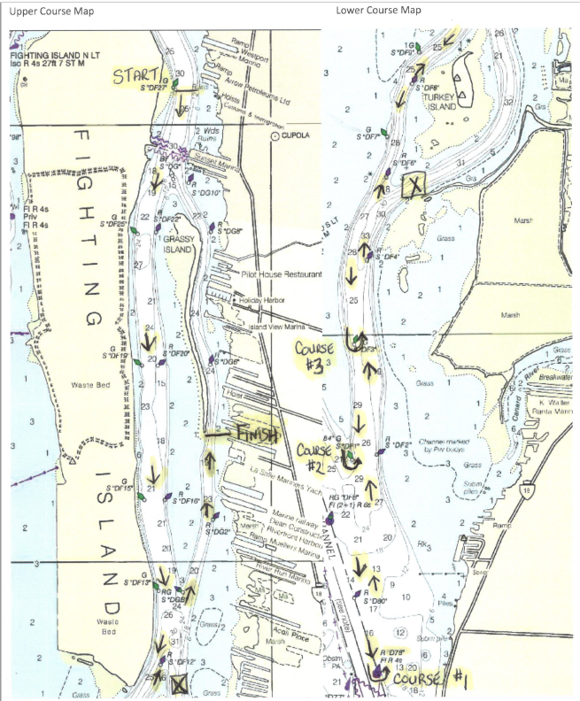

Let’s have a great race and great day together. Good luck competitors!

